Design of VLSI Circuits and Systems Lab
Dept. of Computer Science & Engineering
University of Rajshahi
DEPARTMENT OF COMPUTER SCIENCE & ENGINEERING

UNIVERSITY OF RAJSHAHI, RAJSHAHI

Part-IV, Semester I
CSE 4152P (VLSI Lab)

Experiment List
S/N | Name of the Experiment
01 | To design and simulate all the logic gates using VHDL.
02 | To design and simulate 1-bit half adder using the gate level modeling style of VHDL.
03 | To design and simulate Full adder using the gate level modeling style of VHDL.
04 | To design and simulate 4:1 Multiplexer using VHDL.
05 | To design and simulate 1:4 Demultiplexer using VHDL.
06 | To design and simulate 3-to-8 line Decoder using VHDL.
07 | To design and simulate 4-to-2 line Encoder using VHDL.
08 | To design and simulate J-K Flip-Flop VHDL.
09 | To design and simulate 4-bit Carry Look-ahead adder using VHDL.
10 | To design and simulate 4-bit BCD adder using VHDL.
11 | To design and simulate 4-bit Binary adder/subtractor using VHDL.
12 | To design and simulate 4-bit Synchronous Counter using VHDL.
13 | To design and simulate 3-bit Asynchronous Counter using the gate level modeling style of VHDL.

Evaluation Process
S/N | Evaluation Criteria | Mode | Marks (%)
1 | Understanding of the given Experiment | Viva/voce | 20
2 | Design | Observation | 20
3 | Implement | Observation | 20
4 | Accuracy Level | Observation | 20
5 | Explanation of the Outcome | Viva/voce | 20

Laboratory Notes
- Students have to keep separate laboratory note book for this lab.
- They have to note down on note successful code of the day and get respective teacher’s signature of their notebooks.
- They have note down the explanation any error/mistake(s) found during the compilation of their code.

Assignment-1

Title: Design and simulate all the logic gates using VHDL.

Outline: Perform Zero Delay Simulation of all the logic gates gate level modeling style in VHDL using a Test bench.
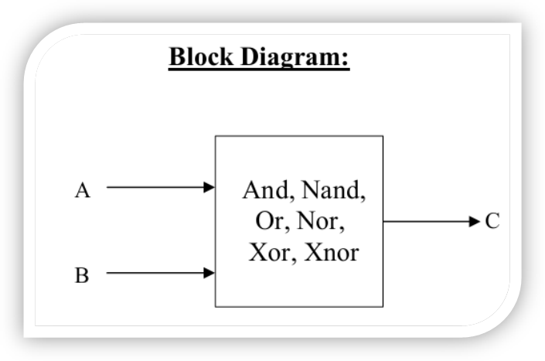
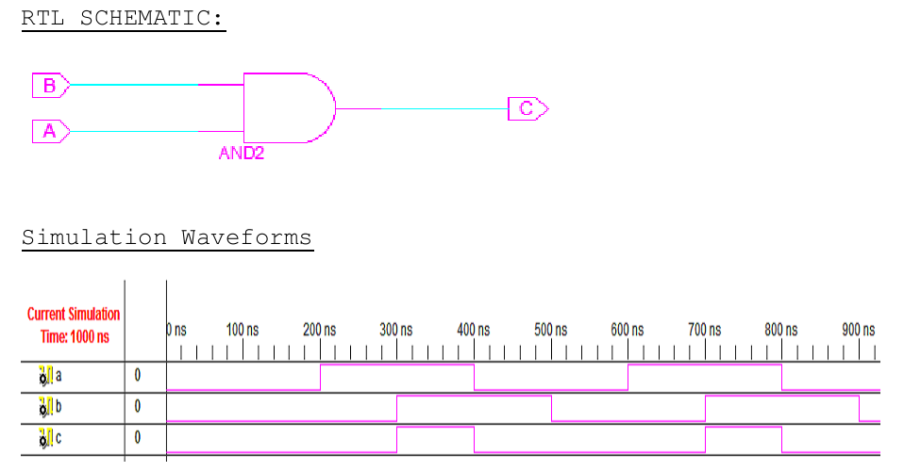
Figure-1: Schematic Diagram and Timing Diagram of AND gate.

Code for AND gate:
module agate(c,a,b);
input a,b;
output c;
wire a,b,c;
and(c,a,b);
endmodule

module agtest;
reg x,y;
wire z;
agate g1(z,x,y);
initial
begin
#5 x=1'b1;
#5 y=1'b1;
#10 x=1'b0;
#20 x=1'b1;
#35 y=1'b0;
#50 y=1'b1;
#120 $finish;
end
initial
$monitor($time, " Input a=%b b=%b Oupput c=%b",x,y,z);
Endmodule

Code for OR gate

module orgate(c,a,b);
output c;
input a,b;
wire a,b,c;
or(c,a,b);
endmodule

module ogtest;
reg x,y;
wire z;
orgate g1(z,x,y);
initial
begin
#5 x=1'b0;
#5 y=1'b1;
#15 y=1'b0;
#25 x=1'b1;
#60 $finish;
end
initial
$monitor($time, " Input a=%b b=%b Output c=%b",x,y,z);
endmodule

Code for NOT gate:

module ngate(a,b);
output a;
input b;
wire a,b;
not(a,b);
endmodule

module testngate;
reg x;
wire y;
ngate g1(y,x);
initial
begin
#10 x=1'b1;
#15 x=1'b0;
#20 x=1'b1;
#24 x=1'b0;
#60 $finish;
end
initial
$monitor($time, "Input b=%b Output a=%b",x,y);
endmodule

Report Writing: For report writing instructions, just follow the following instructions:
- Name of the Program
- Program Areas
- Objectives
- Design Circuits
- Truth Table

Mode of Evaluation: Presentation, Implementation & Testing, and Viva.
Assignment-2

Title: Design and simulate 1-bit half adder using the gate level modeling style of VHDL.

Outline:Perform Zero Delay Simulation of 1-bit half adder written in Gate level modeling style in VHDL using a Test bench.

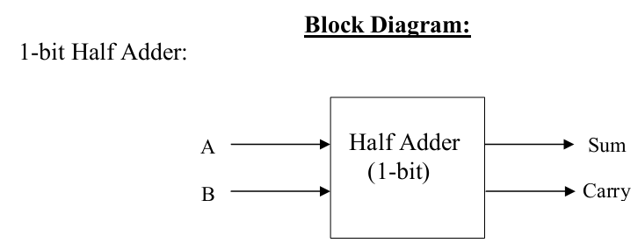 | 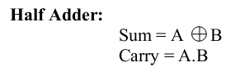

Figure-2: Schematic Diagram of 1-bit Half adder.

Code for Half Adder:

module
halfadder(a,b,sum,carry);
input a,b;
output sum, carry;
wire sum, carry;
assign sum = a^b; // sum bit
assign carry = (a&b) ; //carry bit
endmodule

module main;
reg a, b;
wire sum, carry;
halfadder add(a,b,sum,carry);

always @(sum or carry)
begin
$display("time=%d:%b + %b = %b,
carry = %b\n",$time,a,b,sum,carry);
end

initial
begin
a = 0; b = 0;
#5
a = 0; b = 1;
#5
a = 1; b = 0;
#5
a = 1; b = 1;
end
endmodule

Report Writing: For report writing instructions, just follow the following instructions:
- Name of the Program
- Program Areas
- Objectives
- Design Circuits
- Truth Table

Mode of Evaluation: Presentation, Implementation & Testing, and Viva.

Assignment-3

Title: Design and simulate Full adder using the gate level modeling style of VHDL.

Outline:Perform Zero Delay Simulation of Full adder written in Gate level modeling style in VHDL using a Test bench.
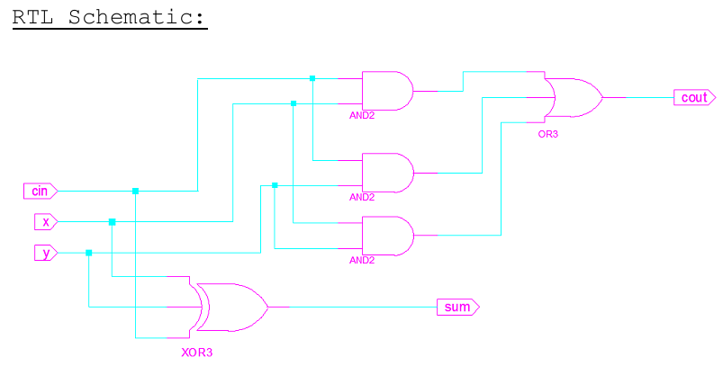
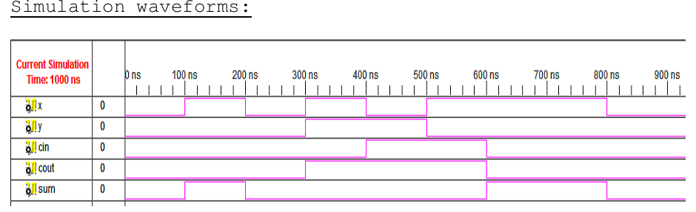
Figure-3: Schematic Diagram of Full adder.

Code for Full Adder:
module fulladder (s,co, a, b, c)
input a, b ,c ;
output co, s ;
xor (n1, a, b) ;
xor (s, n1, c) ;
nand (n2, a, b) ;
nand (n3,n1, c) ;
nand (co, n3,n2) ;
endmodule

module main;
reg a, b, cin;
wire sum, carry;
fulladder add(sum,carry, a,b,cin);

always @(sum or carry)
begin
$display("time=%d:%b + %b +%b = %b,
carry = %b\n",$time,a,b,cin,sum,carry);
end

initial
begin
a = 0; b = 0; cin=0;
#5
a = 0; b = 1; cin=0;
#5
a = 1; b = 0; cin =1;
#5
a = 1; b = 1; cin=1;
end
endmodule

Report Writing: For report writing instructions, just follow the following instructions:
- Name of the Program
- Program Areas
- Objectives
- Design Circuits
- Truth Table

Mode of Evaluation: Presentation, Implementation & Testing, and Viva.

Assignment-4

Title: Design and simulate 4:1 Multiplexer using the gate level modeling style of VHDL.

Outline:Perform Zero Delay Simulation of 4:1 Multiplexer written in Gate level modeling style in VHDL using a Test bench.

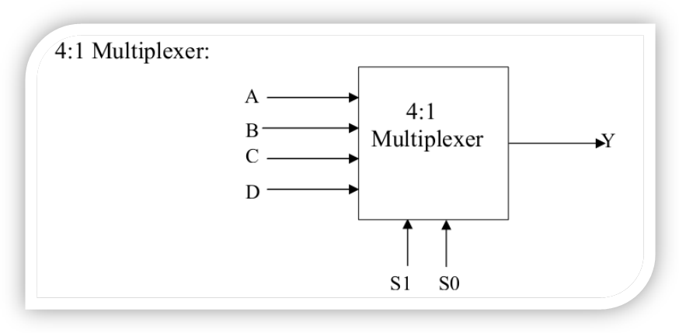
Figure-4: Schematic Diagram of 4:1 Multiplexer.

Code for Multiplexer:

module mux(out,i0,i1,i2,i3,s0,s1);
output out;
input i0,i1,i2,i3,s0,s1;
wire y0,y1,y2,y3,ns0,ns1;
not(ns0,s0);
not(ns1,s1);
and(y0,i0,ns1,ns0);
and(y1,i1,s1,ns0);
and(y2,i2,s1,ns0);
and(y3,i3,s1,s0);
or #10 or1(out,y0,y1,y2,y3);
endmodule

module muxtest;
reg I0,I1,I2,I3,S0,S1;
wire out1;
mux m1(out1,I0,I1,I2,I3,S0,S1);
initial
begin
I0=1;
I1=0;
I2=1;
I3=0;
#5 S0=0;
#5 S1=1;
#15 S0=0;
#60 $finish;
end
initial
$monitor($time, " Inputs I1=%b I2=%b I3=%b I4=%b S0=%b S1=%b Output out=%b",I0,I1,I2,I3,S0,S1,out1);
Endmodule

Report Writing: For report writing instructions, just follow the following instructions:
- Name of the Program
- Program Areas
- Objectives
- Design Circuits
- Truth Table

Mode of Evaluation: Presentation, Implementation & Testing, and Viva.

Assignment-5

Title: Design and simulate 1:4 Demultiplexer using the gate level modeling style of VHDL.

Outline:Perform Zero Delay Simulation of 1:4 Demultiplexer written in Gate level modeling style in VHDL using a Test bench.
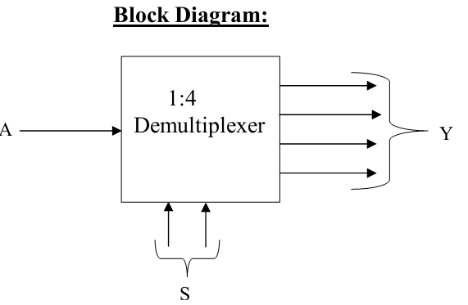 | 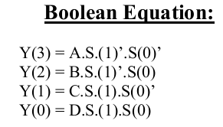

Figure-5: Schematic Diagram of 1:4 Demultiplexer.
Code:
module demultiplexer1_4 ( din ,x ,y ,a ,b ,c ,d );
output a ;
output b ;
output c ;
output d ;

input din ;
input x ;
input y ;

assign a = din & (~x) & (~y);
assign b = din & (~x) & y;
assign c = din & x & (~y);
assign d = din & x & y;

endmodule

Report Writing: For report writing instructions, just follow the following instructions:
- Name of the Program
- Program Areas
- Objectives
- Design Circuits
- Truth Table

Mode of Evaluation: Presentation, Implementation & Testing, and Viva.

Assignment-6

Title: Design and simulate 3-to-8 line Decoder using the gate level modeling style of VHDL.

Outline:Perform Zero Delay Simulation of 3-to-8 line Decoder written in Gate level modeling style in VHDL using a Test bench.
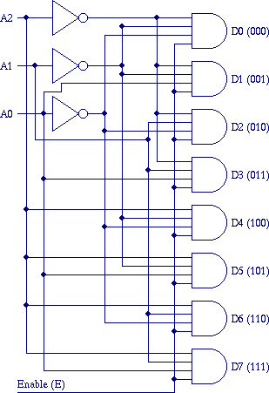
Figure-6: Schematic Diagram of 3-to-8 line Decoder.

Code:
module decoder(o,enb_,sel ) ;
output [7:0] o ;
input enb_ ;
input [2:0] sel ;
reg [7:0] o ;

always @ (enb_ or sel)
if (enb _)
o = 8'b1111_1111 ;
else
case(sel)
3'b000 : o = 8'b1111_1110 ;
3'b001 : o = 8'b1111_1101 ;
3'b010 : o = 8'b1111_1011 ;
3'b011 : o = 8'b1111_0111 ;
3'b100 : o = 8'b1110_1111 ;
3'b101 : o = 8'b1101_1111 ;
3'b110 : o = 8'b1011_1111 ;
3'b111 : o = 8'b0111_1111 ;
default : o = 8'bx ;
endcase
endmodule

Report Writing: For report writing instructions, just follow the following instructions:
- Name of the Program
- Program Areas
- Objectives
- Design Circuits
- Truth Table

Mode of Evaluation: Presentation, Implementation & Testing, and Viva.

Assignment-7

Title: Design and simulate 4-to-2 line Encoder using the gate level modeling style of VHDL.

Outline:Perform Zero Delay Simulation of 4-to-2 line Encoder written in Gate level modeling style in VHDL using a Test bench.
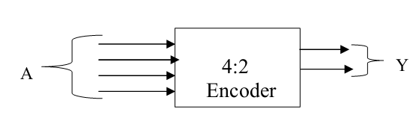 | 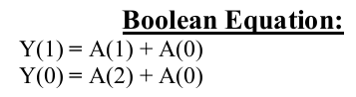

Figure-7: Schematic Diagram of 4-to-2 line Encoder.

Code:
module encoder4_2 ( a ,b ,c ,d ,x ,y );

output x ;
output y ;

input a ;
input b ;
input c ;
input d ;

assign x = b | d;
assign y = c | d;

endmodule

Report Writing: For report writing instructions, just follow the following instructions:
- Name of the Program
- Program Areas
- Objectives
- Design Circuits
- Truth Table

Mode of Evaluation: Presentation, Implementation & Testing, and Viva.

Assignment-8

Title: Design and simulate J-K Flip-Flop using the gate level modeling styleof VHDL.

Outline:Perform Zero Delay Simulation of J-K Flip-Flop written in Gate level modeling style in VHDL using a Test bench.
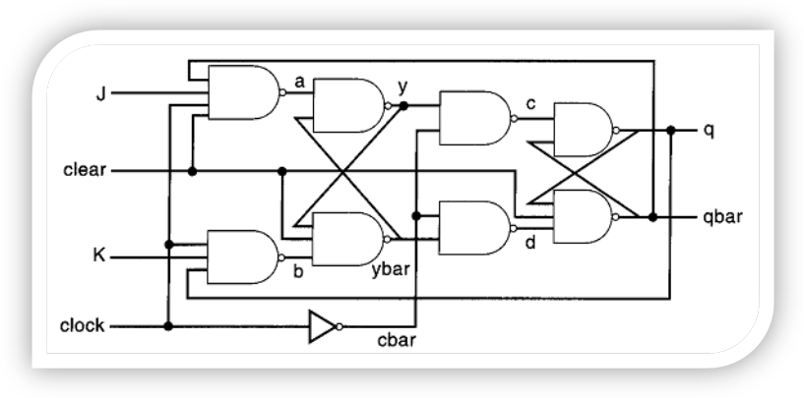
Figure-8: Schematic Diagram of J-K Flip-Flop.

Code for FF:

module jkflipflop(j,k,clr,clk,q,qbar);
input j,k,clr,clk;
output q,qbar;
wire j,k,clr,clk,q,qbar,a,b,y,ybar,c,d,cbar;

assign a=~(j & clk &clr & qbar),
b=~(k & clk & q);
assign y=~(a & ybar),
ybar=~(y & clr & b);
assign cbar=~clk;

assign c=~(cbar & y),
d=~(cbar & ybar);

assign q=~(qbar & c),
qbar=~(q & clr & d);

endmodule

module test;

reg J,K,CLK,CLR;
wire Q,QBAR;

jkflipflop jk(J,K,CLR,CLK,Q,QBAR);

initial
begin
J=1'b0;
K=1'b0;
CLR=1'b0;
#10 CLR=1'b1;
#9 J=1'b1;
K=1'b1;
#11 J=1'b0;
K=1'b0;
#7 J=1'b1;
K=1'b1;
end
initial
begin
CLK=1'b0;
forever #10 CLK=~CLK;
end

initial
#100 $finish;
endmodule

Report Writing: For report writing instructions, just follow the following instructions:
- Name of the Program
- Program Areas
- Objectives
- Design Circuits
- Truth Table

Mode of Evaluation: Presentation, Implementation & Testing, and Viva.

Assignment-9

Title: Design and simulate 4-bit Carry Look-ahead adder using the gate level modeling style of VHDL.

Outline:Perform Zero Delay Simulation of 4-bit Carry Look-ahead adder written in Gate level modeling style in VHDL using a Test bench.
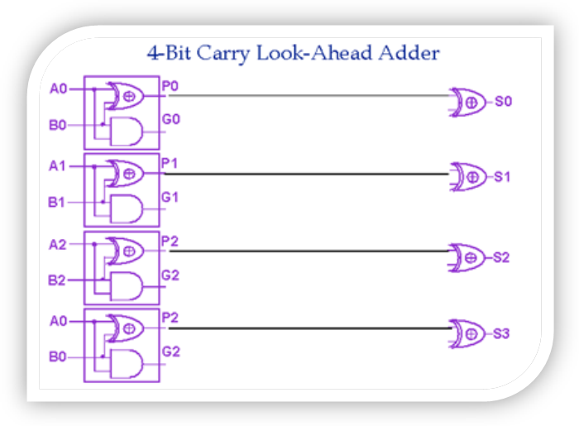
Figure-9: Schematic Diagram of 4-bit Carry Look-ahead adder.

Code:

module CLA_4bit( output [3:0] S, output Cout,PG,GG, input [3:0] A,B, input Cin);
wire [3:0] G,P,C;

assign G = A & B; //Generate
assign P = A ^ B; //Propagate
assign C[0] = Cin;
assign C[1] = G[0] | (P[0] & C[0]);
assign C[2] = G[1] | (P[1] & G[0]) | (P[1] & P[0] & C[0]);
assign C[3] = G[2] | (P[2] & G[1]) | (P[2] & P[1] & G[0]) | (P[2] & P[1] & P[0] & C[0]);
assign Cout = G[3] | (P[3] & G[2]) | (P[3] & P[2] & G[1]) |
(P[3] & P[2] & P[1] & G[0]) |(P[3] & P[2] & P[1] & P[0] & C[0]);
assign S = P ^ C;

assign PG = P[3] & P[2] & P[1] & P[0];
assign GG = G[3] | (P[3] & G[2]) | (P[3] & P[2] & G[1]) | (P[3] & P[2] & P[1] & G[0]);
endmodule

module Test_CLA_4bit;
// Inputs
reg [3:0] A;
reg [3:0] B;
reg Cin;

// Outputs
wire [3:0] S;
wire Cout;
wire PG;
wire GG;

// Instantiate the Unit Under Test (UUT)
CLA_4bit uut ( .S(S), .Cout(Cout), .PG(PG), GG(GG), .A(A), .B(B), .Cin(Cin));

initial begin
// Initialize Inputs
A = 0; B = 0; Cin = 0;
// Wait 100 ns for global reset to finish
#100;

// Add stimulus here
A=4'b0001;B=4'b0000;Cin=1'b0;
#10 A=4'b100;B=4'b0011;Cin=1'b0;
#10 A=4'b1101;B=4'b1010;Cin=1'b1;
#10 A=4'b1110;B=4'b1001;Cin=1'b0;
#10 A=4'b1111;B=4'b1010;Cin=1'b0;
end

initial begin
$monitor("time=",$time,, "A=%b B=%b Cin=%b : Sum=%b Cout=%b PG=%b GG=%b",A,B,Cin,S,Cout,PG,GG);
end
endmodule

Report Writing: For report writing instructions, just follow the following instructions:
- Name of the Program
- Program Areas
- Objectives
- Design Circuits
- Truth Table

Mode of Evaluation: Presentation, Implementation & Testing, and Viva.

Assignment-10

Title: Design and simulate 4-bit BCD adder using the gate level modeling style of VHDL.

Outline:Perform Zero Delay Simulation of 4-bit BCD adder written in Gate level modeling style in VHDL using a Test bench.
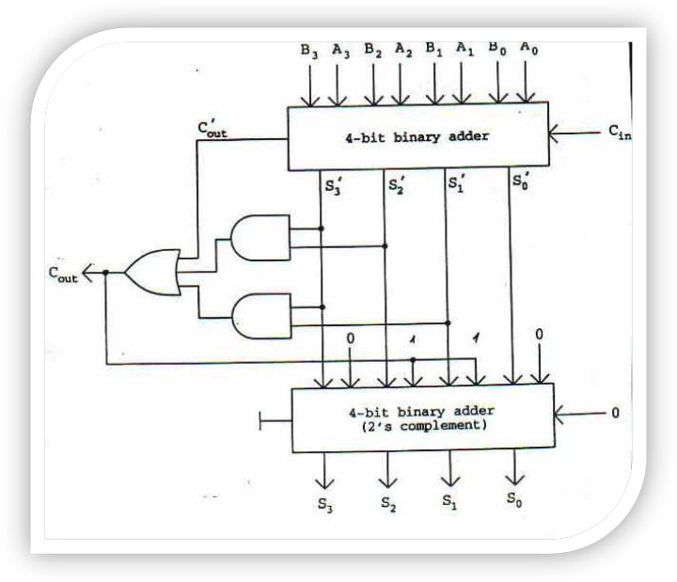
Figure-10: Schematic Diagram of 4-bit BCD adder.

Code:
module full_adder(sum,cout,cin,inp1,inp2);
input cin, inp1, inp2;
output sum,cout;
wire w1,w2,w3;
xor x1(w1,inp1,inp2);
xor x2(sum,w1,cin);
and a1(w2,inp1,inp2);
and a2(w3,w1,cin);
or(cout,w2,w3);
endmodule

module four_bit(cout,sum,x,y,cin);
input [3:0] x,y;
input cin;
output [3:0] sum;
output cout;
wire d1,d2,d3;
full_adder f1(sum[0],d1,x[0],y[0],cin);
full_adder f2(sum[1],d2,x[1],y[1],d1);
full_adder f3(sum[2],d3,x[2],y[2],d2);
full_adder f4(sum[3],cout,x[3],y[3],d3);
endmodule

module bcd_adder (caout,out,ag,au,carryin);
input [3:0] ag,au;
input carryin;
output [3:0] out;
output caout;
wire [3:0] w;
wire [3:0] h;
wire w1,w2,w3,w4,w5;
four_bit add1(w1,w,ag,au,carryin);
and a1(w2,w[2],w[3]);
and a2(w3,w[1],w[3]);
or r1(w4,w1,w2,w3);
xor in20(h[0],w4,w4);
or in21(h[1],w4,w4);
or in23(h[2],w4,w4);
xor in24(h[3],w4,w4);
four_bit add2(w5,out,w,h,carryin);
or inca(caout,w4,w4);
endmodule

Report Writing: For report writing instructions, just follow the following instructions:
- Name of the Program
- Program Areas
- Objectives
- Design Circuits
- Truth Table

Mode of Evaluation: Presentation, Implementation & Testing, and Viva.

Assignment-11

Title: Design and simulate 4-bit Binary adder/subtractor using the gate level modeling style of VHDL.

Outline:Perform Zero Delay Simulation of 4-bit Binary adder/subtractor written in Gate level modeling style in VHDL using a Test bench.
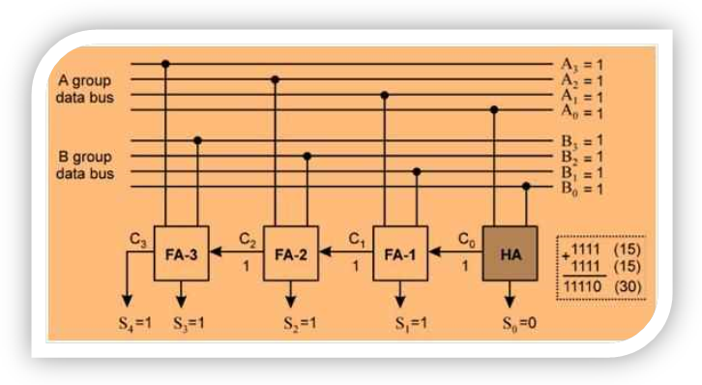
Figure-11: Schematic Diagram of 4-bit Binary adder/subtractor.
Report Writing: For report writing instructions, just follow the following instructions:
- Name of the Program
- Program Areas
- Objectives
- Design Circuits
- Truth Table

Mode of Evaluation: Presentation, Implementation & Testing, and Viva.

Assignment-12

Title: Design and simulate 4-bit Synchronous Counter using the gate level modeling style of VHDL.
Outline:Perform Zero Delay Simulation of 4-bit Synchronous Counter written in Gate level modeling style in VHDL using a Test bench.
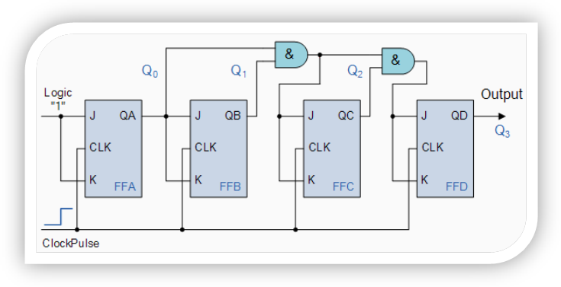
Figure-12: Schematic Diagram of 4-bit Synchronous Counter.
Code:
module tb_counter();

reg clk_1fs;
reg rst_n;
reg [3:0] r_count;
reg [3:0] count;
reg count_en;

initial begin
clk_1fs = 0;
rst_n = 0;
#100 rst_n = 1;
forever begin
#10 clk_1fs = 1;
#10 clk_1fs = 0;
end
end

always@(posedge clk_1fs or negedge rst_n)

begin
if (!rst_n)
begin
r_count <= 'b0;
count_en <= 'b0;
end
else
begin
r_count <= count;
end
end

always@(*)
begin
count = r_count;
if (r_count < 15 && !count_en)
begin
count = r_count + 1;
end
else if (r_count == 15)
begin
count_en = 1;
count = 15;
end
else count = 15;
end
endmodule

Report Writing: For report writing instructions, just follow the following instructions:
- Name of the Program
- Program Areas
- Objectives
- Design Circuits
- Truth Table

Mode of Evaluation: Presentation, Implementation & Testing, and Viva.

Assignment-13

Title: Design and simulate 3-bit Asynchronous Counter using the gate level modeling styleof VHDL.

Outline:Perform Zero Delay Simulation of 3-bit Asynchronous Counter written in Gate level modeling style in VHDL using a Test bench.
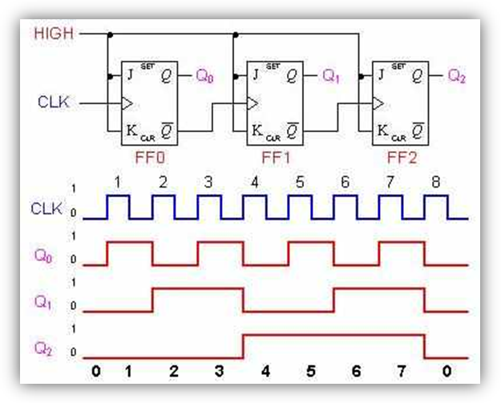
Figure-13: Schematic Diagram of 3-bit Asynchronous Counter.
Code for counter:

module counter(clr,clk,ce,q0,q1,q2,q3);
input clr,clk,ce;
output q0,q1,q2,q3;
wire ce,clr,clk,q,qbar,a,b,y,ybar,c,d,cbar,c1,c2,c3,q11,q22,q33,q44;
jkflipflop j1(ce,ce,clr,clk,q0,q11);
assign c1=q0 & ce;
jkflipflop j2(c1,c1,clr,clk,q1,q22);
assign c2=q1 & c1;
jkflipflop j3(c2,c2,clr,clk,q2,q33);
assign c3=q2 & c2;
jkflipflop j4(c3,c3,clr,clk,q3,q44);

endmodule
module test;
reg CE,CLK,CLR;
wire Q0,Q1,Q2,Q3;
counter ck(CLR,CLK,CE,Q0,Q1,Q2,Q3);
initial
begin
CE=1'b0;
#5 CE=1'b1;
CLR=1'b0;
#5 CLR=1'b1;

end
initial
begin
CLK=1'b1;
forever #5 CLK=~CLK;
end
initial
#100 $finish;
endmodule

Report Writing: For report writing instructions, just follow the following instructions:
- Name of the Program
- Program Areas
- Objectives
- Design Circuits
- Truth Table

Mode of Evaluation: Presentation, Implementation & Testing, and Viva.

